Online Coaching Form
Please complete and email the following form.
(Insert Name Here)
Age:
Height:
Weight: (average)
Goals: (Short / Long term)
Photos:
(Front / Side / Rear)
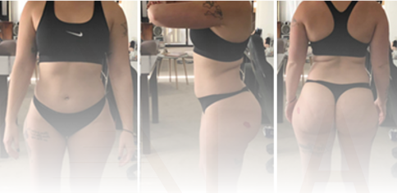
Current Training:
*what you are doing currently i.e. walking, swimming, cycling, weights etc.
Current Nutrition:
*i.e. counting calories, food frequency, supplements, meal plan / meal prep / food logging etc.
Current Education:
*what have you learnt? What would you like to learn?
Note: you must be willing to learn about Energy (Calorie) Balance.
Focus areas? (pick 3)
*i.e. legs, glutes, core.
Coaching Service:
*Click here to select a service.
Timeframe:
*estimated weeks to diet? Show date?
Medical Restrictions?
*any relevant information i.e. blood work, disorders etc.
www.thelabpersonaltraining.com
Strength. Conditioning. Nutrition. © Copyright Pty Ltd. All Rights Reserved 2020 The Lab - Personal Training. Franz Cruz

